Restraint and Its Limits
Earning the right to change, and the right to spend — a strategic review of Swanzey's fiscal and governance record

Prepared for the Swanzey Board of Selectmen
PublicLogic VAULT · Working draft v0.1 · June 2026
Built entirely from the Town's own annual reports (2011–2025), NH DRA, and local news
A working draft, offered for discussion — to be cut back to what the board judges realistic.

1. Purpose and posture
This is a mirror, not a critique. Every figure in it comes from the Town of Swanzey's own annual reports and public records — the budgets you proposed, the articles you warranted, and the votes residents cast. We assembled fifteen years of that record into one picture because patterns that are invisible in any single town meeting become clear across a decade and a half.
We make three promises in these pages. First, we credit what has worked — and a great deal has. Second, we lead with data, not opinion. Third, we propose only what Swanzey can realistically afford and actually pass. A town earns the right to change by understanding itself, and earns the right to spend by proving stewardship. This paper tries to do both, in that order.
The argument in one sentence: Swanzey leads with restraint; restraint built deep voter trust for a decade; and restraint, used the same way for another decade, will quietly starve the Town's capital and erode the very trust it built. The fix is not to abandon restraint — it is to upgrade it.

2. Executive summary
Across fifteen years of official-ballot meetings, Swanzey's electorate is remarkably consistent: it funds operations, rewards saving, and refuses debt. That instinct produced something valuable — for years, roughly four in five voters approved the budget. But three things are now true at once, and together they mark an inflection point.
$5.75M → $8.94M | operating budget, 2012 → 2026 (+55%); now +6–7%/yr
81% → 57% | operating-budget support has fallen ~24 points
0 of 2 | public works facility bonds passed (failed the 3/5 wall in 2024 and 2026)
78–90% | pass rate for capital reserves and tax credits — the town will save, not borrow
$47K | 2026 gap between the proposed and default budget — the 'vote no to save' lever is gone

Read together, the record says Swanzey does not have a willpower problem or a spending problem. It has a structure problem: the instruments the town reaches for (lean annual budgets and the occasional bond) no longer fit the scale of what it must now do — absorb a water utility, replace a public-works facility, and carry a decade of deferred capital. The good news is that a better-fitting set of instruments already exists, and the town has quietly begun using them.

3. First, credit where it is due
Before a word about change, the record deserves real credit — and none of the strain the town feels is the board's fault.
- Low debt, lived values. Swanzey carries little long-term debt; debt service is a small share of the budget. That is a genuine achievement and a real gift to taxpayers.
- Disciplined saving. When asked to set money aside, residents say yes by large margins — capital reserves and tax credits pass with 78–90% support. The town has the saving habit most communities wish for.
- Faith kept with voters. For a decade, budgets passed with ~80% approval. That trust was earned, not given.
- Willingness to modernize governance. Voters expanded the Select Board from three to five (2025) and kept the SB2 ballot they value — the town is actively tuning how it governs.
- Already pioneering smart finance. In 2025 the town moved to acquire the West Swanzey water system and funded a study expecting full principal forgiveness through the state revolving fund. That is exactly the kind of financing this paper recommends — the instinct is already here.
And the pressures are not self-inflicted. The cost drivers pushing the budget up 6–7% a year — health insurance, wages, the state retirement system, and the ambulance contract — are largely non-discretionary. The three-fifths threshold that sinks bond votes is state law, not local stubbornness. The 2024 'rate drop' that confuses taxpayers was a revaluation required by the state. And administrator turnover reflects a competitive regional labor market. The board has been making rational choices inside hard constraints.
4. The pattern: the town leads with restraint
If you watch what Swanzey consistently chooses, a single posture emerges — restraint. It shows up three ways in the data.
Restraint 1 — voters say yes to small and no to big. The same electorate that gives tax credits about 90% support and reserve deposits roughly 78% gives facility bonds only 55–58%. It is not that residents oppose the projects; they decline the instrument (debt) and the threshold (3/5) that comes with it.
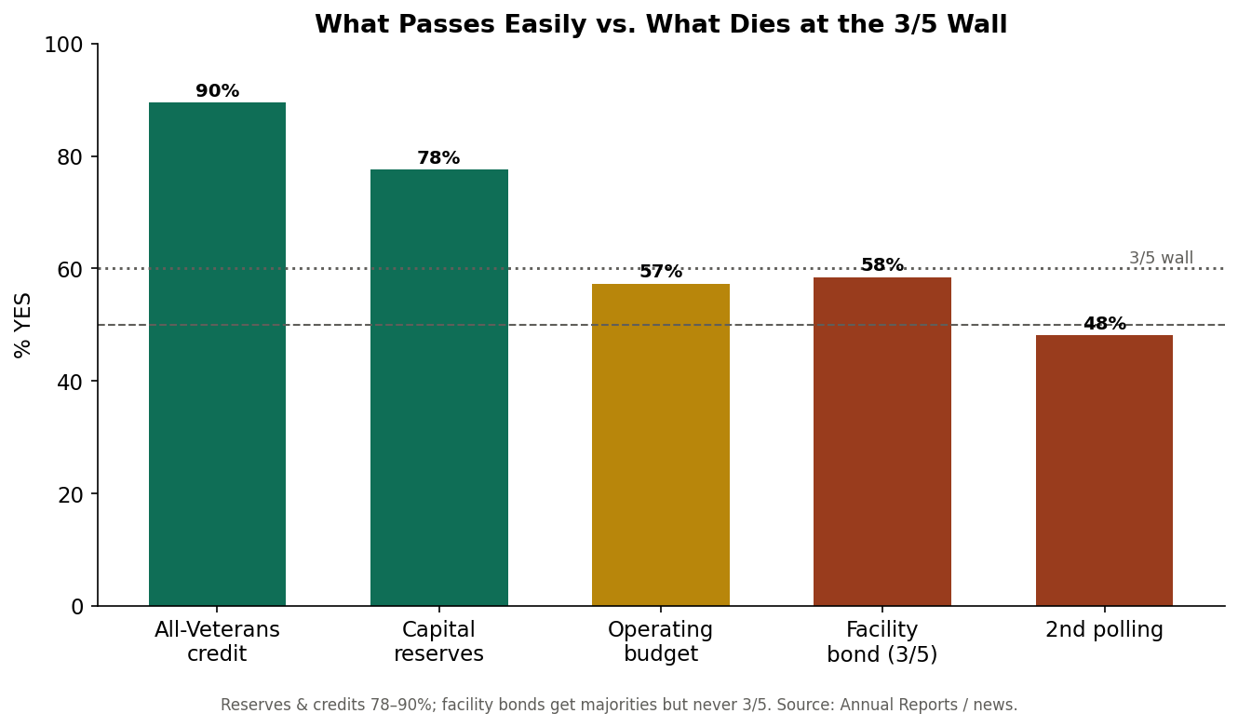
What passes easily versus what dies at the 3/5 wall. The pattern is the instrument, not the project.
Restraint 2 — the budgets are already lean. In an SB2 town a 'no' vote installs the default budget. In Swanzey the default now sits within ~$47K of the proposal — and in 2017, 2018, and 2023 it actually exceeded it. There is no fat the default would trim; proposals are built close to the bone.
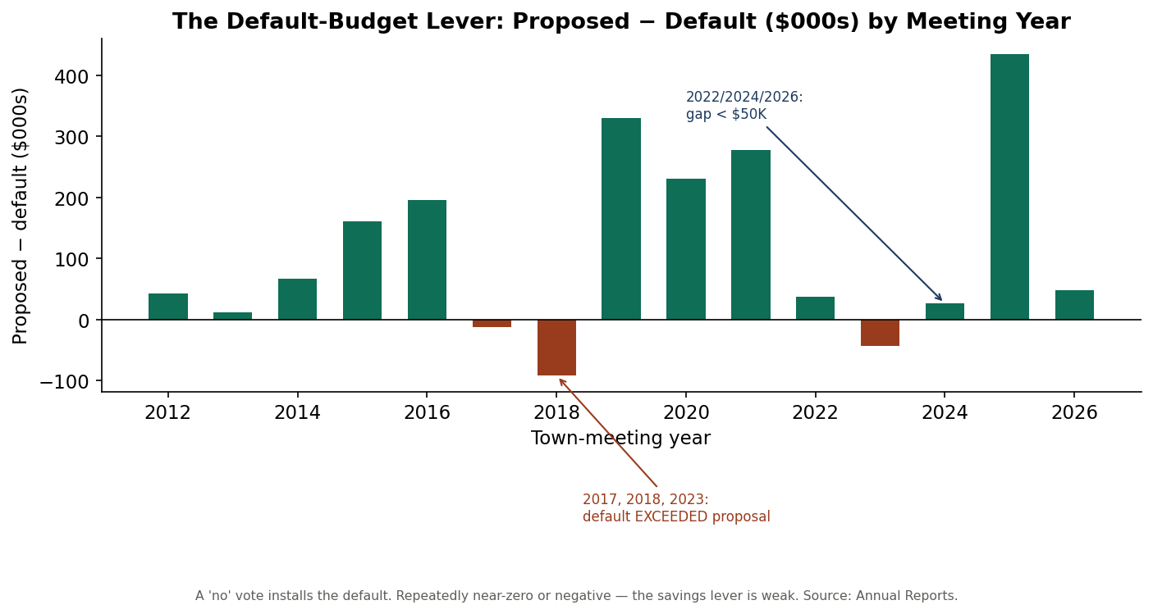
Proposed minus default budget. Repeatedly near zero or negative — restraint is already maxed out.
For most of the period, this restraint paid a dividend in trust: budget approval ran near 80%.

5. The hidden cost of leading with restraint
Restraint that defers investment does not make the need go away — it compounds it. Deferred maintenance is a tax increase the town has not named yet, and the bill is coming due in three places.
- A public-works facility with no plan and no piggy bank. The facility won majorities in 2024 and 2026 and failed both times at 3/5. There was no capital reserve quietly funding it over the prior decade — so a real need has no vehicle and no momentum.
- A water system to absorb. The West Swanzey acquisition is the right move, but it is a multi-million obligation that restraint-by-deferral cannot carry.
- Executive churn. Three administrators in roughly two years. Some of that is the labor market — and some is the strain of steering a town caught between rising needs and a habit of saying no.
And here is the turn. Around 2016 the trend line bent. Operating-budget support has fallen from ~80% to 57% — roughly twenty-four points — even as the town held the line on taxes. The restraint that once bought confidence is now spending it, because residents can see the deficits it produces.
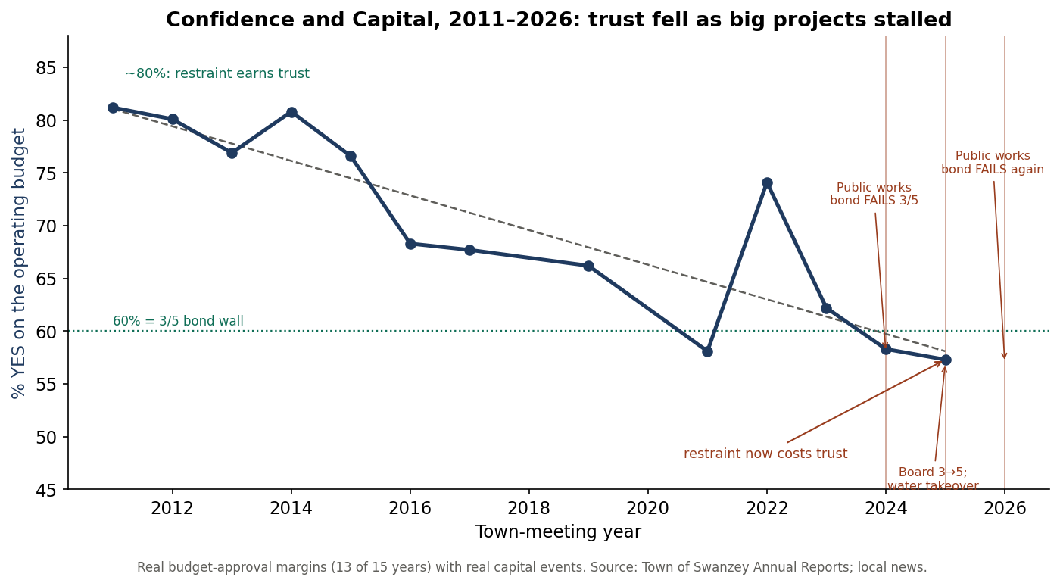
Real budget-approval margins with real capital events. As restraint persisted and big projects stalled, confidence fell.
6. The inflection — stated plainly, and kindly
So here is the difficult part, said as plainly and as respectfully as we can: the instinct is right, but the instrument has turned against the goal.
Caution is a virtue, and Swanzey's caution is real and admirable. But for a decade the town has asked restraint to do something restraint cannot do — fund a water utility and a capital backlog by saying no. Continuing exactly as before will not protect the town's trust; it will keep spending it, one stalled project at a time. That is not a failure of will or of values. It is a financing structure that has simply outlived the moment it was built for.
The error, named nicely: the goal is a well-run, affordable town. Restraint serves that goal right up until it blocks the investment the goal requires. Swanzey is now on the wrong side of that line — not by much, and not irreversibly, but clearly enough to act.

7. Earning the right to change
Change in a town like Swanzey is earned, not imposed. Three principles make it legitimate.
- Understand before reforming. This paper, built from your own record, is the first step — and the reason it leads with credit, not criticism.
- Stabilize before you build. Nothing else holds if the administrator's office turns over annually. Continuity is the foundation every other recommendation rests on.
- Change the instrument, not the values. Keep the restraint. Keep the low debt and the saving habit. Change only the tool — from 'refuse debt' to 'save first and leverage other people's money.'
Concretely, that means two early, low-cost moves: a multi-year continuity compact with the administrator, and a short, written set of decision rules so the board and staff route every capital question the same way. Both appear in the toolkit (Section 9).
What we would do differently — and why
Today the Town leads with… | We would lead with… | Why
“No” to debt | “Save first, then leverage aid” | Keeps restraint; unlocks capital at a simple majority instead of 3/5
Lean annual budgets only | A published six-year capital plan | Turns surprises into expectations; lets the rate be smoothed
One-off bond asks | Majority-vote capital reserves | Clears the 3/5 wall the town keeps hitting
Tax-rate headlines | Bill-and-value transparency | Defuses the revaluation confusion that erodes trust
Reacting to turnover | An administrator continuity compact | Protects every other initiative from resetting
Case-by-case land use | Criteria-based decisions on the record | Reduces litigation exposure (e.g., Avanru)

8. Earning the right to spend
The structural insight is simple and freeing: a bond needs a three-fifths supermajority — the wall Swanzey keeps hitting — but a capital reserve fund needs only a simple majority, which the town grants readily. Save up, pay cash, and the scary vote disappears. Better still, most of the backlog can be carried by money that is not the property tax at all.
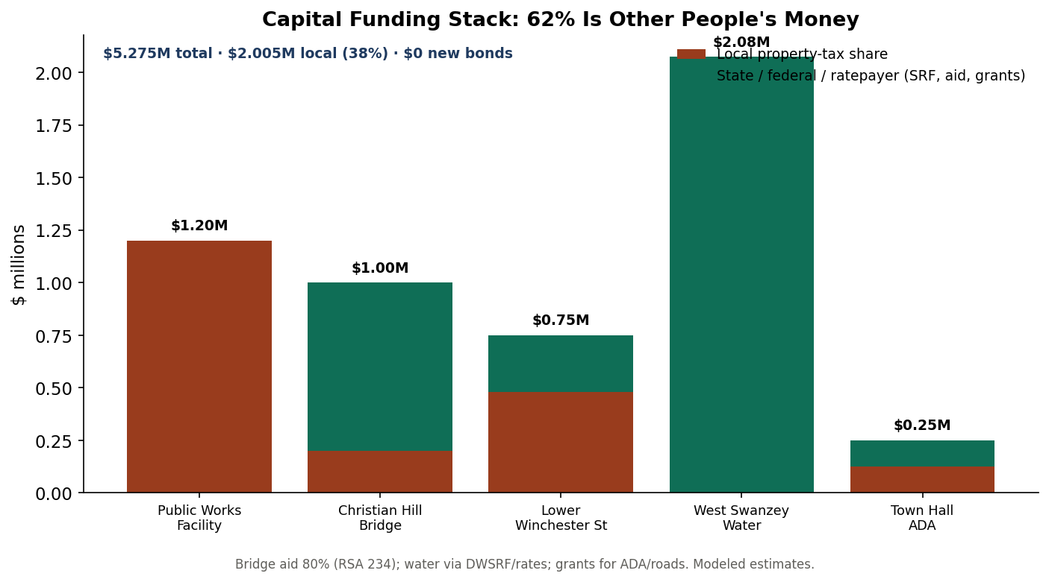
Of ~$5.3M in identified needs, about 62% can be carried by state bridge aid, water rates (DWSRF), and grants — leaving a local share the town can save toward.
Run the local share through majority-vote reserves on a phased schedule and the tax impact is modest and temporary: it peaks around $75 a year on a $300,000 home, then falls below today's once the backlog clears and the projects are built.
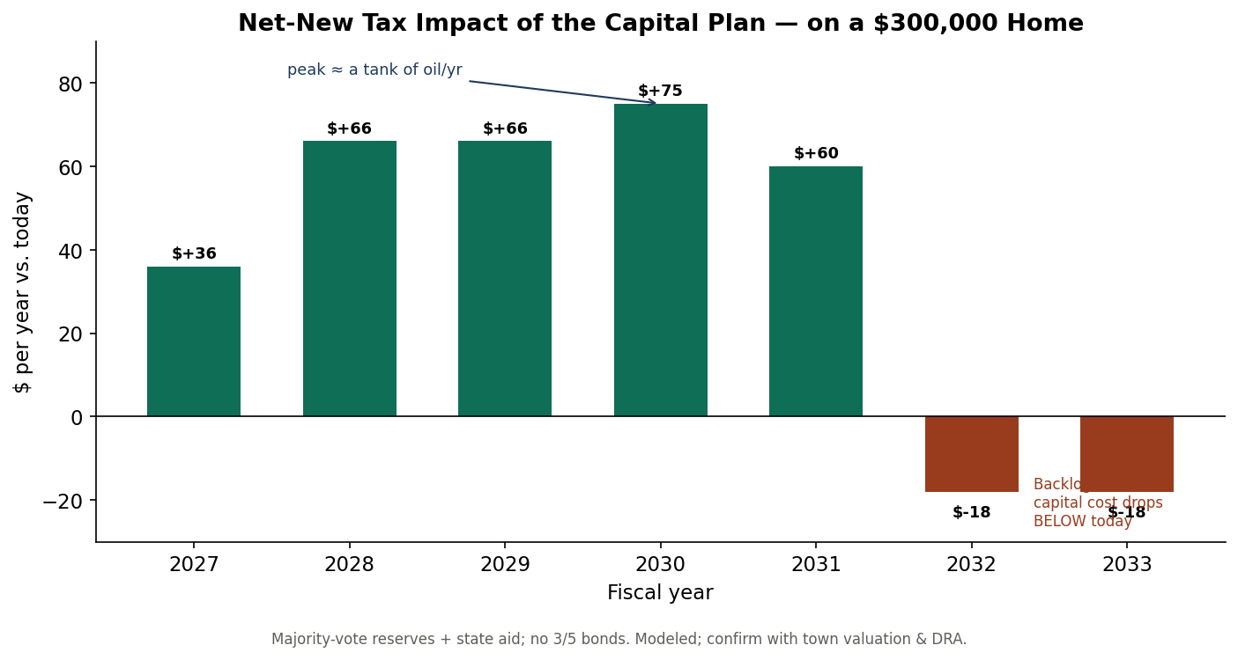
Net-new tax impact of the financing plan on a $300,000 home — a brief, small climb, then below today.
This is how a town earns the right to spend. Each step — a funded reserve balance residents can see, a grant secured, a published plan kept, a tax bill honestly explained — is a deposit in the trust account. After two or three cycles of kept promises, the next big ask is no longer a leap of faith; it is the plan working. The town has already made the first deposit with the water-fund strategy. The task is to do it on purpose, everywhere.

9. A practical toolkit
Six tools the board can adopt without waiting for anyone's permission.
Tool 1 — The capital reserve ladder (majority-vote)
Capital Reserve Fund | Suggested annual deposit | Funds | Vote
Public Works Facility | $150–300K | the facility, pay-go by ~2031 | majority
Bridges | $50K | Christian Hill 20% share (state pays 80%) | majority
Highway Reconstruction | $100K | Lower Winchester St & roads | majority
Highway Equipment | $90K | plow/fleet replacement cycle | majority
Fire Apparatus | $70K | engine/tanker cycle | majority
Town Facilities (incl. ADA) | $40K | Town Hall ADA, building renewal | majority
Technology & Records | $20K | GIS, cyber, RSA 33-A retention | majority

Tool 2 — Decision rules (route every capital question the same way)
If the project is… | Use… | Because
≤ ~$250K and recurring | a capital reserve (pay-go) | simple majority, zero interest
a town bridge (≥10-ft span) | State Bridge Aid (RSA 234) + reserve for the 20% | the state pays 80%
water or sewer | the DWSRF, repaid by user rates | keeps it off the property tax
large, urgent, unavoidable | the NH Bond Bank (RSA 33) — last resort | only when reserves can't get there in time
any of the above | listed in the published CIP first | converts a surprise into an expectation

Tool 3 — The administrator continuity compact
- A multi-year employment agreement with clear severance and notice.
- A written annual evaluation against goals the board and administrator set together.
- A board–administrator delegation policy that defines lanes: policy is the board's, administration is the administrator's.
- A documented transition/onboarding packet so turnover never resets the town's institutional memory.
- Compensation benchmarked to the regional market — continuity is cheaper than churn.
Tool 4 — The tax-bill explainer (one page for residents)
Your bill = your assessed value × the tax rate ÷ 1,000. In a revaluation year (like 2024) values rise and the rate falls — so a lower rate is not a tax cut. About 60% of the bill is school and county, set outside Town Hall. The municipal portion — the part the Select Board controls — is roughly a quarter of the total.

Tools 5 and 6 — a six-year CIP template and DRA-compliant model warrant articles for the reserve ladder — are included in the companion workbook and capital plan and are ready to fill in.

10. Landing it — a twelve-month plan
None of this requires a leap. It requires a sequence — each step small, affordable, and trust-building.
Quarter | Moves
Q1 (months 1–3) | Stabilize the administrator (multi-year agreement + evaluation). Publish a draft six-year CIP. Issue the one-page tax-bill explainer.
Q2 (4–6) | Warrant and pass establishment of the capital reserve ladder (majority votes). File the State Bridge Aid application for Christian Hill Road. Commission the water rate study.
Q3 (7–9) | Advance DWSRF water financing. Deliver one visible 'small win' (e.g., Town Hall ADA via CDBG + the facilities reserve). Adopt operating norms for the five-member board.
Q4 (10–12) | Bring the full CIP and reserve plan to the deliberative session with a pre-meeting information night. Report the year's progress publicly — a trust deposit.

The ask
Endorse one principle — keep the restraint, change the instrument — and direct staff to (1) stabilize the administrator, (2) stand up the capital reserve ladder and a published CIP, and (3) pursue state bridge aid and DWSRF financing for the largest items. No new bonds. No tax spike. A path to fund the backlog entirely within the values the town already holds.
Restraint built this town's trust. Used a little differently — to save first, to leverage the money already on the table, and to tell residents the plain truth — that same restraint can build the town. That is the whole of the recommendation.

Provenance: real figures are from the Town of Swanzey's own annual reports (2011–2025), NH DRA, and local news; capital figures and forecasts are clearly-labeled planning estimates. The trend and magnitudes do not depend on any single number.

